**PRACTICAL – 2(6)**

**Aim: Perform following functionalities of the string:**

* **Find Length of the String**
* **Lowercase of the String**
* **Uppercase of the String**
* **Reverse String**
* **Sort the string**

**SOURCE CODE:**

import java.util.Arrays;

import java.util.Scanner;

public class Practical2_7 {

    public static *void* main(String[] *args*) {

        String str_1;

        Scanner sc = new Scanner(System.in);

        System.out.println("Enter String: ");

        str_1 = sc.nextLine();

        System.out.println("\nLength of String is: " + str_1.length());

        System.out.println("Lower Case String is: " + str_1.toLowerCase());

        System.out.println("Upper Case String is: " + str_1.toUpperCase());

        StringBuilder rev = new StringBuilder();

        rev.append(str_1);

        rev.reverse();

        System.out.println("Reverse String is: " + rev);

*char*[] chars = str_1.toCharArray();

        Arrays.sort(chars);

        String sorted = new String(chars);

        System.out.println("Sorted String is: " + sorted);

        System.out.println("\n20DCE019-Yatharth Chauhan");

    }

}

**OUTPUT:**

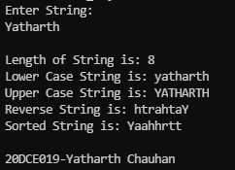

**CONCLUSION:**

* In this practical we learned how to use length() method, toUpperCase(), toLowerCase() method, reverse() method & Array.